Myntra Fashion Clone
Project Documentation

Project Information
Field | Details
Project Name | Myntra Fashion Clone
Repository | GitHub Link
Submitted By | T.PAVAN MANI KUMAR
Roll No | AV.SC.U4CSE25152
Course | User Interface Design (23CSE113), SEM-2
Submitted To | Dr. Rajkumar Batchu, Assistant Professor, CSE
Document Date | 19 May 2026

1. Project Overview
The Myntra Fashion Clone is a responsive frontend recreation of the popular Myntra e-commerce platform. The project focuses on creating a modern shopping interface with product browsing, filtering, cart management, wishlist functionality, and user account features. The website showcases advanced CSS layouts, JavaScript interactivity, responsive design principles, and a premium fashion retail experience.

Homepage View
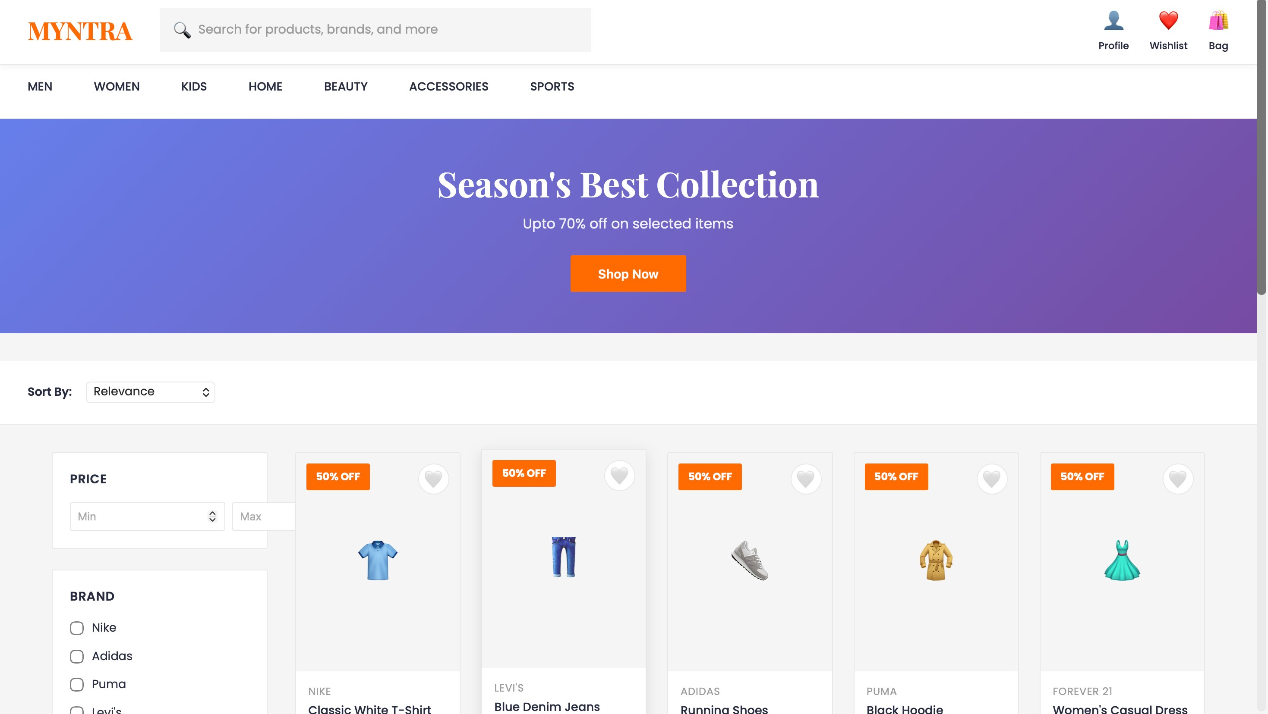
Figure 1: Myntra Clone - Homepage with product grid, filters, and navigation

2. Objectives
- Recreate the visual appearance and functionality of the Myntra e-commerce website.
- Design a responsive fashion retail shopping interface.
- Implement interactive product filtering and sorting mechanisms.
- Create shopping cart and wishlist management features.
- Showcase product details in modal views with size and color selection.
- Practice advanced CSS layouts, responsive design, and JavaScript functionality.
- Improve frontend development skills using HTML5, CSS3, and vanilla JavaScript.

3. Technology Stack
Technology | Purpose
HTML5 | Website structure, semantic markup, and content organization
CSS3 | Styling, layouts, animations, responsive design, and grid systems
JavaScript (Vanilla) | Interactive elements, filtering, cart management, and dynamic rendering
Google Fonts | Typography (Poppins, Playfair Display) and branding

4. Project Structure
myntra_clone/
├── myntra.html
├── styles.css (embedded)
├── script.js (embedded)
└── README.md

5. Main Features

5.1 Header & Navigation
- Sticky header with logo and branding
- Search bar with icon for product discovery
- Cart and wishlist buttons with item counters
- Profile section for user account access

5.2 Navigation Bar
- Horizontal category navigation (MEN, WOMEN, KIDS, HOME, BEAUTY, ACCESSORIES, SPORTS)
- Active state highlighting
- Smooth hover transitions

5.3 Banner Section
- Eye-catching promotional banner
- Gradient background (Purple to Blue)
- Call-to-action "Shop Now" button

5.4 Filters Section
- Price range filtering
- Brand filter with checkboxes
- Sort options (Relevance, Price, Newest, Rating)

5.5 Product Grid
- Dynamic product cards with hover effects
- Brand name and product name display
- Price display with discounts
- Quick add to cart button
- Wishlist toggle

5.6 Product Modal
- Detailed product view in modal overlay
- Size selection options
- Color selection with visual swatches
- Star rating and review count display
- Add to Bag functionality
- Wishlist toggle button

5.7 Shopping Cart
- Display all added items
- Quantity adjustment controls
- Item removal functionality
- Subtotal and total calculations
- Checkout button

5.8 Wishlist
- Favorite items management
- Product grid view of wishlist items
- Quick add to cart from wishlist

5.9 User Profile
- User account information display
- Order history section
- Settings and preferences

Product Detail Modal
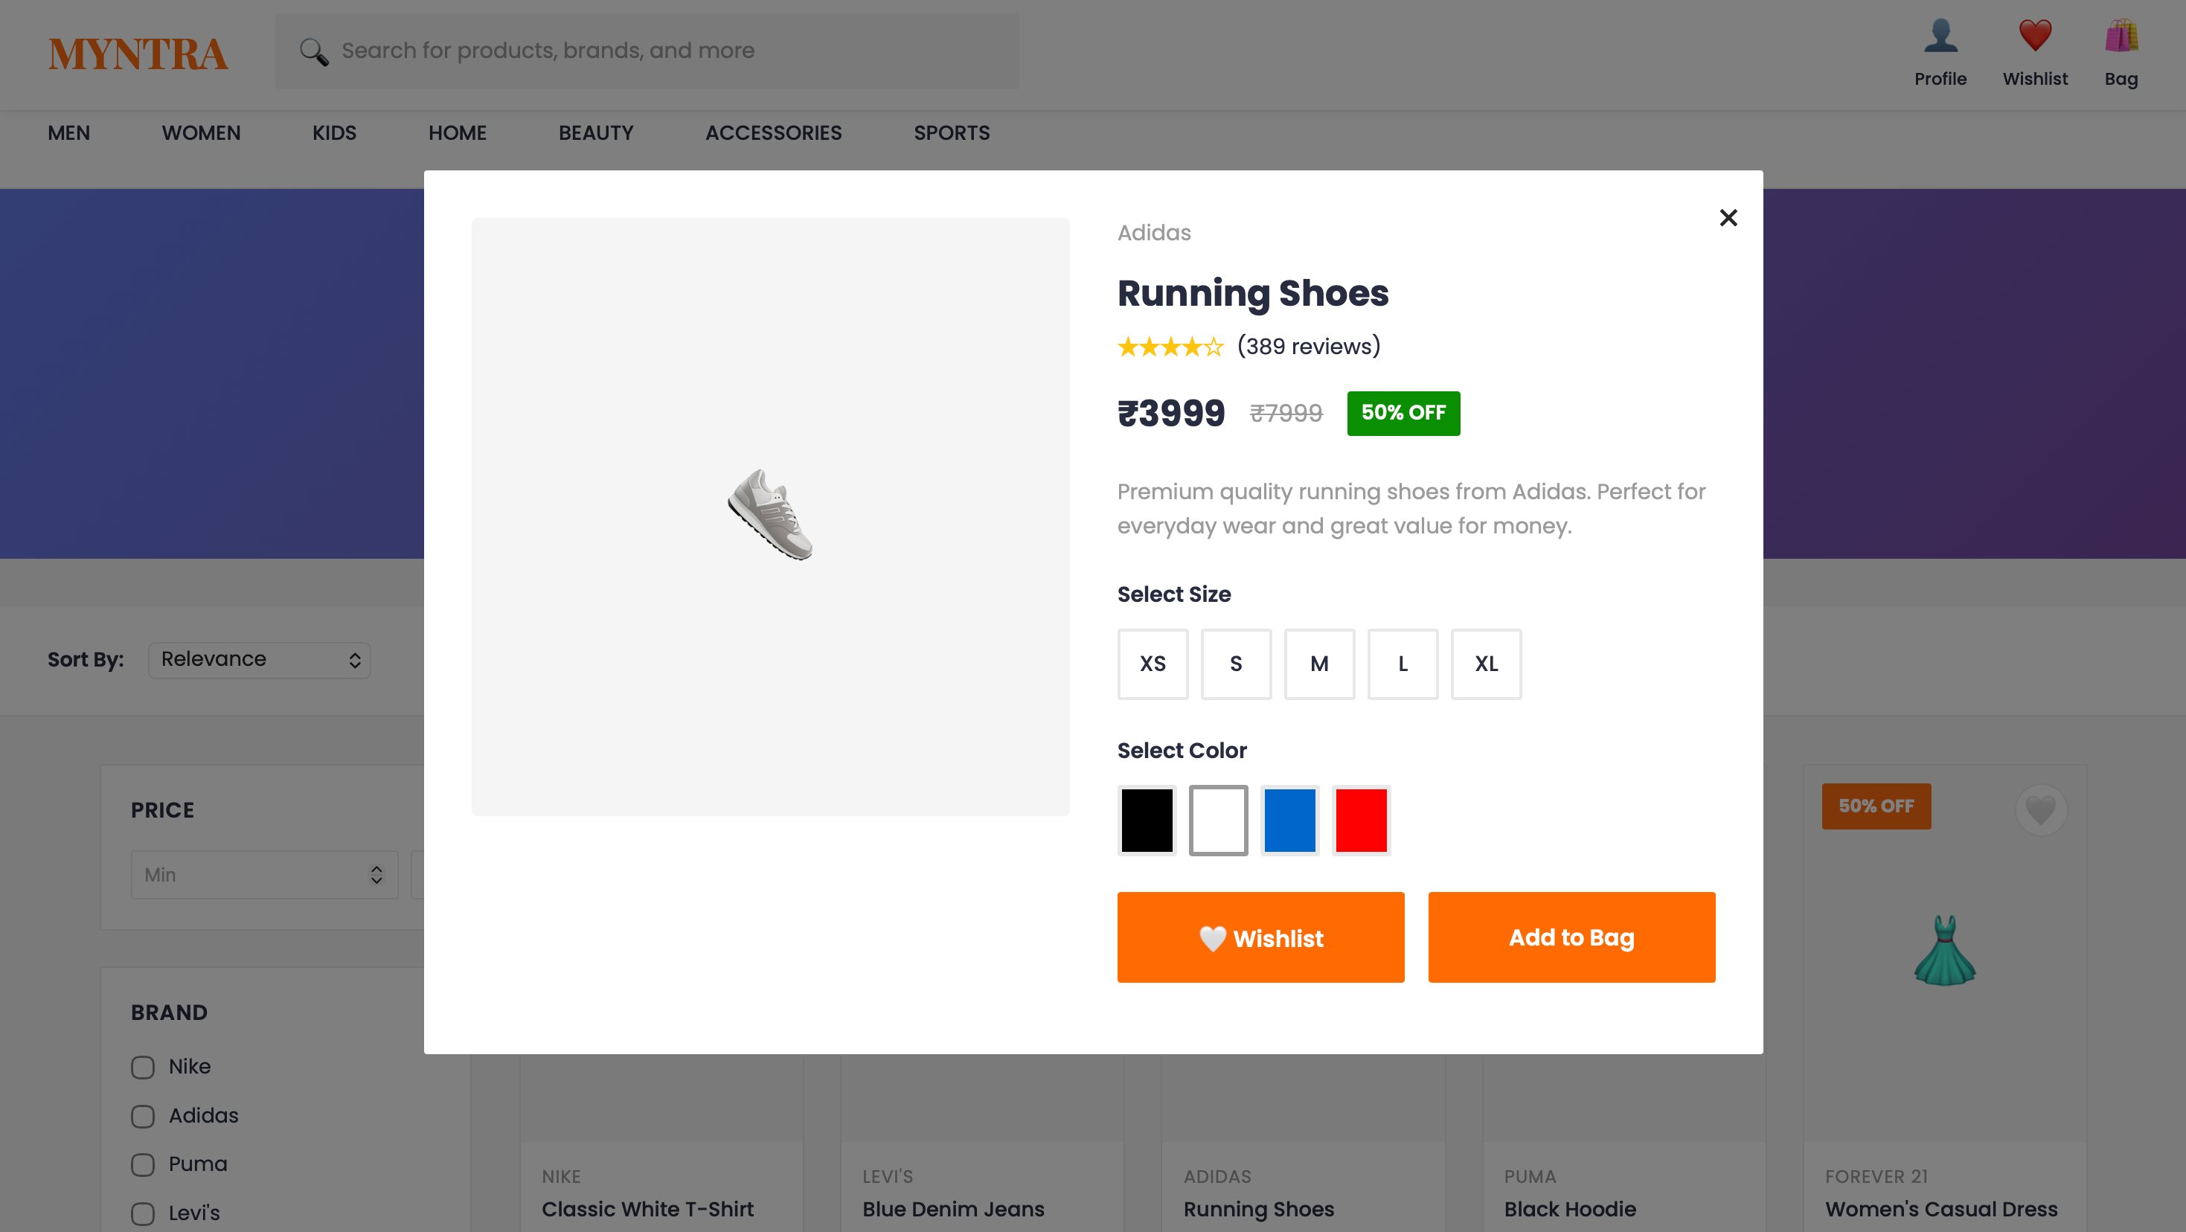
Figure 2: Product detail modal showing size, color selection, and pricing

6. Design Approach
The website follows Myntra's modern, user-friendly fashion e-commerce branding approach.

Color Palette
Color | Usage
Myntra Orange (#ff6b00) | Primary branding, buttons, and highlights
Dark Orange (#e55000) | Hover effects and active states
Dark Gray (#282c3f) | Main text and headings
Light Gray (#9b9b9b) | Secondary text and disabled states
White (#ffffff) | Background and card backgrounds

7. Responsive Design
Device | Design Features
Desktop | Full navigation menus, multi-column product grid, sidebar filters
Tablet | Optimized grid layouts, responsive product cards, simplified filters
Mobile | Stacked layouts, single-column product grid, touch-friendly buttons

Shopping Bag / Cart Page
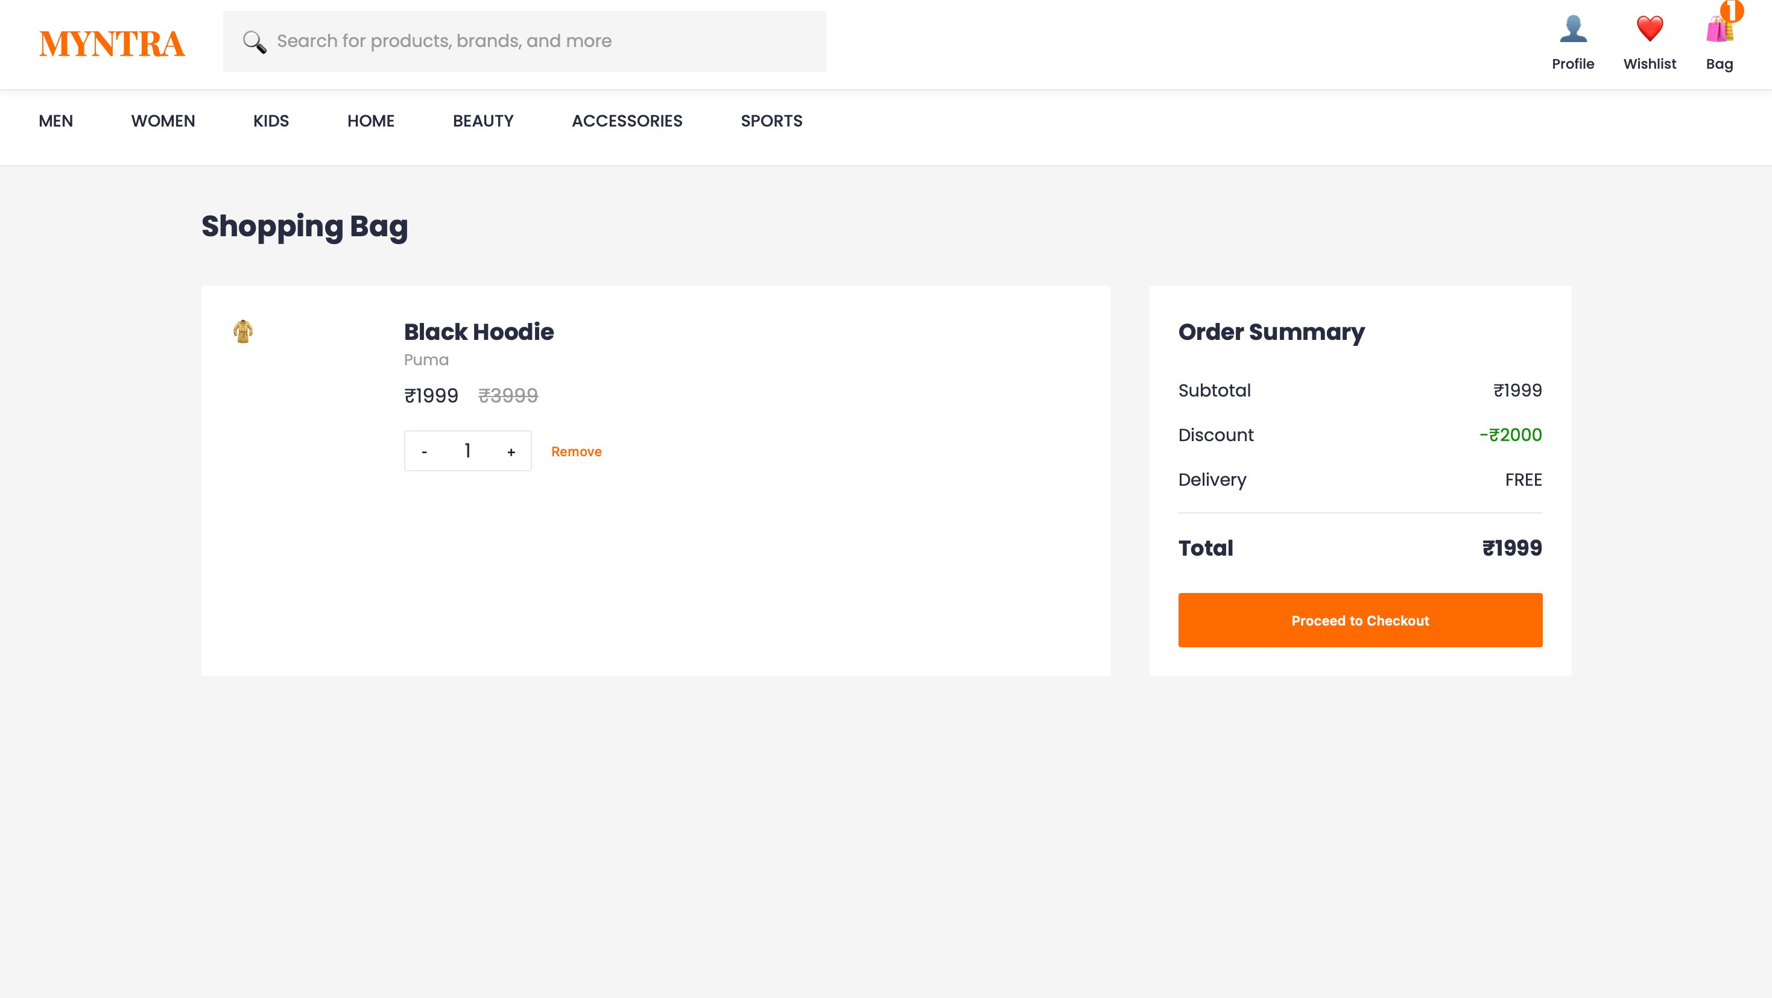
Figure 3: Shopping bag with order summary, quantity controls, and checkout

8. Learning Outcomes
- Mastered HTML5 semantic structuring for e-commerce layouts
- Advanced CSS Grid and Flexbox for responsive design
- JavaScript DOM manipulation and dynamic rendering
- Implementation of filter and search functionality
- Shopping cart and wishlist state management
- Modal windows and overlay implementations
- Responsive web design principles
- E-commerce UI/UX design best practices

9. Limitations
- Frontend-only implementation without backend
- Product data is static and hardcoded
- No real payment gateway integration
- User authentication is not implemented
- No persistent database (uses localStorage only)

10. Future Enhancements
- Backend integration with Node.js and Express
- Database implementation with MongoDB
- User authentication and authorization
- Real payment gateway integration
- Advanced search and recommendations
- Order tracking system

11. Conclusion
The Myntra Fashion Clone successfully demonstrates modern frontend development techniques through a comprehensive e-commerce interface. This project provides a solid foundation for building full-stack e-commerce applications.

